**28 January 2022**

**Australia reveals first details of its presentation in Venice for the Biennale Arte 2022**

* **The Australia Council for the Arts has announced the first details of Marco Fusinato’s presentation at the Biennale Arte 2022, Venice, curated by Alexie Glass-Kantor.**
* ***DESASTRES* is the title of the presentation that will run from 23 April to 27 November 2022.**
* ***DESASTRES* is an experimental noise project that synchronises sound with image and takes the form of a durational solo performance as installation.**
* **The artist will be performing during the opening hours of the Biennale – a total of 200 days.**
* **The presentation will be the first time the Australian Pavilion, located in the historic Giardini della Biennale, has been the site for a live durational performance.**

Originally from the Veneto region in Italy, Marco Fusinato’s parents migrated to Australia where he was born. He currently lives and works in Naarm/Melbourne. Fusinato is a contemporary artist and noise-musician whose work takes the form of installation, photographic reproduction, design, performance and recording. *DESASTRES* is a culmination of his interests in noise/experimental music, underground culture, mass media images and art history.

Developed in Naarm/Melbourne during its extended COVID-19 lockdown, the work embraces all the associated frustrations, pessimism and turmoil. **Fusinato**, who was isolated at home and unable to access his studio during this period, **says** of the development of *DESASTRES*, “I’m interested in the tensions around opposing forces like noise versus silence, order versus disorder, the institution versus the underground, purity versus contamination. These binaries co-exist and in *DESASTRES* it’s that friction I want to maintain – not eliminate. I feel like these tensions are always rubbing up against each other and the interesting thing is how one deals with these agitations, with the contradictions. It’s that in-between state that I want to occupy.”

*DESASTRES* is a visceral experience of sound and image that places the audience at the centre of the work. Fusinato will perform live in the pavilion using an electric guitar as a signal generator into mass amplification to improvise slabs of noise, saturated feedback and discordant intensities that trigger a deluge of images. The resulting all-consuming experience is open for the audience to interpret and make sense of.

**Fusinato says**: “My idea of activating the audience is to remind them that they are alive. That they have a pulse. My work always begins with something I want to experience.”

**Glass-Kantor says**: “*DESASTRES* breaks from the traditional exhibition format. This is not a static exhibition, but an evolving work. We will be live for the entire 200 days of the Biennale Arte in Venice and every time an audience experiences the work, it will be unique. The intensity of the conditions in which this project evolved has allowed the work to be fully embodied as the complete disaster. The performance of the work isn’t about theatre but the act of labour and perseverance.”

For Fusinato, representing Australia at Venice holds particular significance. His first language, and the language spoken by his parents as he was growing up, is a Venetian dialect of the contadini from the Veneto region. Fusinato says the centuries-old oral traditions, passed down through the generations, are disappearing within his lifetime.

**He says:** “I’m going back to exactly the same place my parents migrated from to represent the country they migrated to. There’s a collapse of time.”

The Australia Council is the commissioner for Australia's National Participation at the 59th International Art Exhibition of La Biennale di Venezia. **CEO Adrian Collette AM says:** “Marco Fusinato has created a powerful work that is the culmination of his career of experimentation and research. Curated by Alexie Glass-Kantor, this presentation will offer audiences an experience like no other – continuing for the duration of the Biennale Arte.”

The artist has also created a ‘Score’ for *DESASTRES.* **He says:** “Creating a score was a way to make tangible the idea of image as sound; the 'Score’ as a proposition. The *‘*Score’ is a selection of images from the archive for *DESASTRES* printed full bleed onto manuscript paper.”

**Glass-Kantor says**, “The images for the ‘Score’ are part of a broader archive that Fusinato has been developing for many years. Every day from today till the opening of the exhibition at the Australian Pavilion, we will release an image of the ‘Score’ across dedicated social platforms as an invitation to engage with the project.”

The exhibition will be accompanied by a publication featuring a new essay by Branden W Joseph, professor of art history at Columbia University and an extensive interview by Alexie Glass-Kantor with Marco Fusinato. There will also be texts by critical theorist and filmmaker Elizabeth Povinelli, AI researcher and author Kate Crawford, writer and curator Chus Martinez, and musicians/outre-guitarists Thurston Moore (Sonic Youth), Stephen O’Malley (SUNN O)))) and Bruce Russell (Dead C). The publication is being co-published by Lenz, an independent Milan-based publisher and the Australia Council. The design for the publication is a collaboration by Ziga Testen and Marco Fusinato.

The exhibition will run in conjunction with the Australia Council’s professional development programs, including the [Biennale Delegates Program](https://australiacouncil.gov.au/investment-and-development/international-engagement/biennale-delegates-participants/) and the [Australian Pavilion Invigilation Program](https://australiacouncil.gov.au/investment-and-development/international-engagement/australian-pavilion-invigilation-program-venice-biennale-2022/).

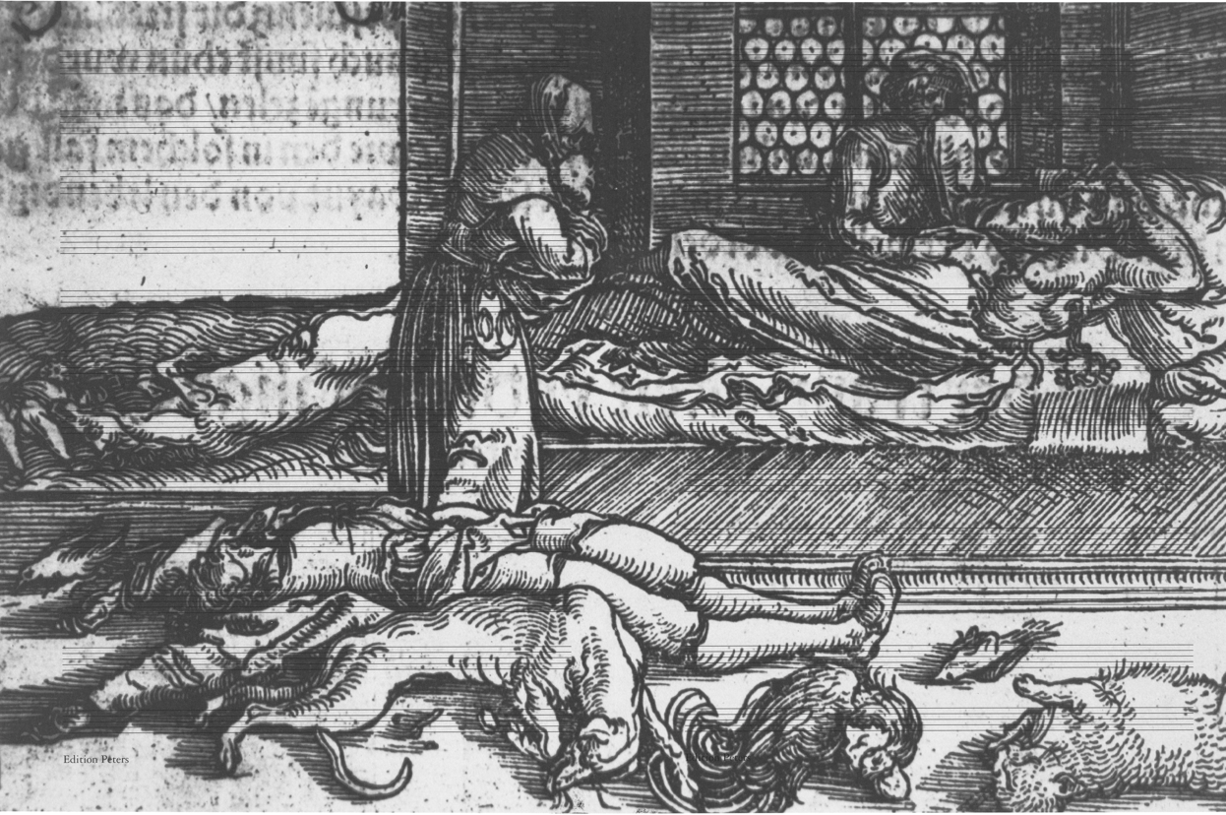

Marco Fusinato  
a selection of pages from the Score for DESASTRES, 2022  
facsimile on Edition Peters manuscript paper  
each 45.5 x 30.3 cm  
Courtesy the artist and Anna Schwartz Gallery

* ENDS -

**For international media enquiries, please contact:**

Alexandra Ross | Sutton

+44 (0) 20 7183 3577 | E: [alexandra@suttoncomms.com](mailto:alexandra@suttoncomms.com)

**For media enquiries within Australia and New Zealand, please contact:**

Claire Martin | ARTICULATE

+61 (0) 414 437 588 | E: [claire@articulatepr.com.au](mailto:claire@articulatepr.com.au)

**Please** [**click here**](https://australiacouncil.gov.au/advocacy-and-research/events/australia-at-the-venice-biennale/venice-biennale-2022/media-centre/) **to download hi-resolution score images and portraits**

**Follow DESASTRES on Instagram** [**@desastres_desastres**](https://www.instagram.com/desastres_desastres/) **for all project updates.**

[**#ausatvenice**](https://aus01.safelinks.protection.outlook.com/?url=https%3A%2F%2Fwww.instagram.com%2Fexplore%2Ftags%2Fausatvenice%2F&data=04%7C01%7CB.Roberts%40australiacouncil.gov.au%7Cb9c32cf8a17b4044abff08d9d65233bd%7C0cb09623aeaf4018a22380d95a375884%7C0%7C0%7C637776470812280980%7CUnknown%7CTWFpbGZsb3d8eyJWIjoiMC4wLjAwMDAiLCJQIjoiV2luMzIiLCJBTiI6Ik1haWwiLCJXVCI6Mn0%3D%7C3000&sdata=x5ov71sfxJieGa9SdIBK0HEYI8ze%2BsJ7y6GdyMrm%2B04%3D&reserved=0)[**#australianpavilion**](https://aus01.safelinks.protection.outlook.com/?url=https%3A%2F%2Fwww.instagram.com%2Fexplore%2Ftags%2Faustralianpavilion%2F&data=04%7C01%7CB.Roberts%40australiacouncil.gov.au%7Cb9c32cf8a17b4044abff08d9d65233bd%7C0cb09623aeaf4018a22380d95a375884%7C0%7C0%7C637776470812280980%7CUnknown%7CTWFpbGZsb3d8eyJWIjoiMC4wLjAwMDAiLCJQIjoiV2luMzIiLCJBTiI6Ik1haWwiLCJXVCI6Mn0%3D%7C3000&sdata=yJDcYpDqoIeNHwSI0i400nI2oRcaiQc6yRJRplRR%2BIk%3D&reserved=0)[**#biennalearte**](https://aus01.safelinks.protection.outlook.com/?url=https%3A%2F%2Fwww.instagram.com%2Fexplore%2Ftags%2Fbiennalearte%2F&data=04%7C01%7CB.Roberts%40australiacouncil.gov.au%7Cb9c32cf8a17b4044abff08d9d65233bd%7C0cb09623aeaf4018a22380d95a375884%7C0%7C0%7C637776470812290973%7CUnknown%7CTWFpbGZsb3d8eyJWIjoiMC4wLjAwMDAiLCJQIjoiV2luMzIiLCJBTiI6Ik1haWwiLCJXVCI6Mn0%3D%7C3000&sdata=DApCjV%2F2FW4M5M2UUz6BRoT4fdBKeszF4t5cKhUyuyk%3D&reserved=0)[**#auspavteam22**](https://aus01.safelinks.protection.outlook.com/?url=https%3A%2F%2Fwww.instagram.com%2Fexplore%2Ftags%2Fauspavteam22%2F&data=04%7C01%7CB.Roberts%40australiacouncil.gov.au%7Cb9c32cf8a17b4044abff08d9d65233bd%7C0cb09623aeaf4018a22380d95a375884%7C0%7C0%7C637776470812290973%7CUnknown%7CTWFpbGZsb3d8eyJWIjoiMC4wLjAwMDAiLCJQIjoiV2luMzIiLCJBTiI6Ik1haWwiLCJXVCI6Mn0%3D%7C3000&sdata=J725guCs9XxKTxi5m8z3pc7eo9deILZf7CvsrZ7WDPc%3D&reserved=0)

**Follow us on:**

Instagram [@desastres_desastres](https://www.instagram.com/desastres_desastres/)

@AusatVenice

Facebook [@AusatVenice](https://www.facebook.com/AusAtVenice)

**About the Artist: Marco Fusinato**

Marco Fusinato is a contemporary artist and noise-musician whose work takes the form of installation, photographic reproduction, design, performance and recording.

As an artist, he conceives his work as a succession of interrelated projects, some of which continue across numerous iterations. Within these projects the works are almost always serial and use specific frameworks for experimentation, as if demonstrating a thesis. Working across disciplines and cultural fields, Fusinato explores the tensions and contradictions of opposing forces: underground culture/institutions, noise/silence, minimalism/maximalism, purity/contamination. He creates dynamic situations in which these energies are captured by combining allegorical appropriation with an interest in the intensity of a gesture or event.

Fusinato’s work has been presented in many international exhibitions, including *All the World’s Futures*, 56th International Art Exhibition of La Biennale di Venezia (2015); *The Imminence of Poetics*, 30th Sao Paulo Biennale (2012); *SUPERPOSITION: Art of Equilibrium and Engagement*, 21st Biennale of Sydney (2018); and *Australia: Antipodean Stories*, Padiglione d’Arte Contemporanea, Milan (2019). His work was also included in *Soundings: A Contemporary Score*, the first ever exhibition of sound at the Museum of Modern Art, New York (2013) and *Sonic Youth etc.: Sensational Fix* (2008–10), a European travelling exhibition of artists who have collaborated with the New York rock band, Sonic Youth.

Fusinato has held regular solo exhibitions at Anna Schwartz Gallery since 2006 including *EXPERIMENTAL HELL (ATMOSPHÆRAM)* (2021); *THIS IS NOT MY WORLD* (2019); *Mass Black Implosion* (2017); *The Infinitives* (2015); *Mass Black Implosion (Treatise, Cornelius Cardew)* (2013); *THERE IS NO AUTHORITY* (2012); *Noise & Capitalism* (2010); *Double Infinitives* (2009) and *The Approaching of The Disco Void-Repeated*, (2006). He has exhibited in numerous solo and group exhibitions in Australian galleries and museums including *The National: New Australian Art*, Museum of Contemporary Art Australia (2017), Sydney; *Parallel Collisions*, Adelaide Biennale of Australian Art, Art Gallery of South Australia, Adelaide (2012); *Melbourne Now*, National Gallery of Victoria, Melbourne (2013); *New09*, Australian Centre for Contemporary Art, Melbourne (2009); and multiple iterations of *Dark Mofo*, Museum of Old and New Art, Hobart (2021, 2019, 2017, 2016, 2014). In 2012 he presented *The Color of the Sky Has Melted*, a survey exhibition at Artspace, Sydney and IMA, Brisbane.

As a musician Fusinato explores the idea of noise as music, using the electric guitar and mass amplification to improvise intricate, wide-ranging and physically affecting frequencies. His ongoing series of durational noise-guitar performances *Spectral Arrows* – described as a monumental aural sculpture – was first performed at The Glasgow International Arts Festival in 2012 and has since been performed in museums and theatres worldwide. He also performs regularly in the experimental music underground, primarily as a solo artist. Fusinato’s first recordings were released in 1996 and he has released many more over subsequent decades, primarily on vinyl format.

Fusinato was the recipient of an Australia Council for the Arts Fellowship in 2016.

Marco Fusinato is represented by Anna Schwartz Gallery.

**About the Curator: Alexie Glass-Kantor**

Alexie Glass-Kantor is a curator, an advocate for the arts and the Executive Director of Artspace, Sydney. Since 2014 she has led the opportunity for co-curated and artist-led projects with peer institutions in 14 countries, including: *Jonathan Jones: untitled (transcriptions of country),* Palais de Tokyo, Paris (2021); 경로를 재탐색합니다 *UN/LEARNING AUSTRALIA*, Seoul Museum of Art (2021); *Taloi Havini:* *Reclamation*, Dhaka Art Summit (2020); *Mel O’Callaghan: Centre of the Centre*, UQ Art Museum, Brisbane (2020) and Le Confort Moderne, Poitiers (2019); *Angelica Mesiti:* *Relay League*, Art Sonje, Seoul (2019) and Kunsthalle Tbilisi, Georgia (2018); *Helen Johnson*, Institute for Contemporary Art, London (2017); and *Nicholas Mangan*: *Ancient Lights*, Chisenhale Gallery, London (2015).

In 2017 Glass-Kantor conceived *52 ARTISTS 52 ACTIONS*, a project which utilised social media to examine socially engaged practice and art-as-action. Since 2015 she has been the curator of *Encounters* for Art Basel | Hong Kong, dedicated to large-scale installations. Glass-Kantor was co-curator with Natasha Bullock of *Parallel Collisions*, the 12th Adelaide Biennial of Contemporary Art (2012) and was in the curatorium for the 13th SITE Santa Fe Biennial, New Mexico. Glass-Kantor is Chair of the Contemporary Art Organisations of Australia and serves on a number of boards and juries including: Academic Board, National Art School, Sydney; Advisory Council, Sydney Contemporary; Advisory Board, Museum of Contemporary Art & Design – De La Salle College of Saint Benilde, Manila; Advance Global Awards jury; and Curatorial Advisory Board, Monash University Curatorial Practice PhD Program. She regularly sits on selection panels for art award and prizes, and participates in public programs, symposiums and lectures across Australia and internationally.

**About Australia Council for the Arts**

The Australia Council is the Australian Government's principal arts investment, development and advisory body and the commissioner for Australia at La Biennale di Venezia. Its purpose is to champion and invest in Australian arts and creativity. The Australia Council invests in arts and organisations through peer assessed grants, fellowships and awards that enable art to be created and experienced.

Australia’s representation at the Biennale in Venice began in 1954, with 40 distinguished contemporary visual artists having the opportunity to exhibit under the Australia banner. Marco Fusinato and Alexie Glass-Kantor make the 41stteam to represent Australia within the Australian Pavilion. The multifaceted project known as Australia at the Venice Biennale encompasses the National Participation within the Australia Pavilion, a suite of professional development opportunities and a unique co-investment campaign which builds advocacy and enables the realisation of the project. The project forms part of Council’s International Engagement Strategy 2021–25.

**About the Australian Pavilion**

The award-winning Australian Pavilion designed by Denton Corker Marshall opened in 2015. Mathew Doyle of the Muruwari people led the smoking ceremony for the Pavilion’s opening. The Pavilion is the first (and currently only) permanent 21st-century structure built in the Giardini della Biennale.

The Australian Pavilion's form was designed to be as simple as possible. The architects describe it as a "white box within a black box, carefully positioned on the site to ensure minimal impact on the existing landscape". Large slabs of black granite give the building its dark exterior. Some panels fold open to reveal the clean white interior and allow some natural light inside. These protruding panels aim to enable the building to take on a new appearance when an exhibition is taking place.

Australia’s Pavilion is one of only 29 national pavilions within the Biennale Gardens, all built at different periods by various countries. The development of the Australian Pavilion was made possible through a public-private partnership led by the Australia Council with the then Commissioner Simon Mordant AM. The original pavilion, designed as a temporary structure by Philip Cox, opened in 1988 and hosted 22 artists during its lifetime.