**Marco Fusinato and Alexie Glass-Kantor to represent Australia at Biennale Arte 2022**

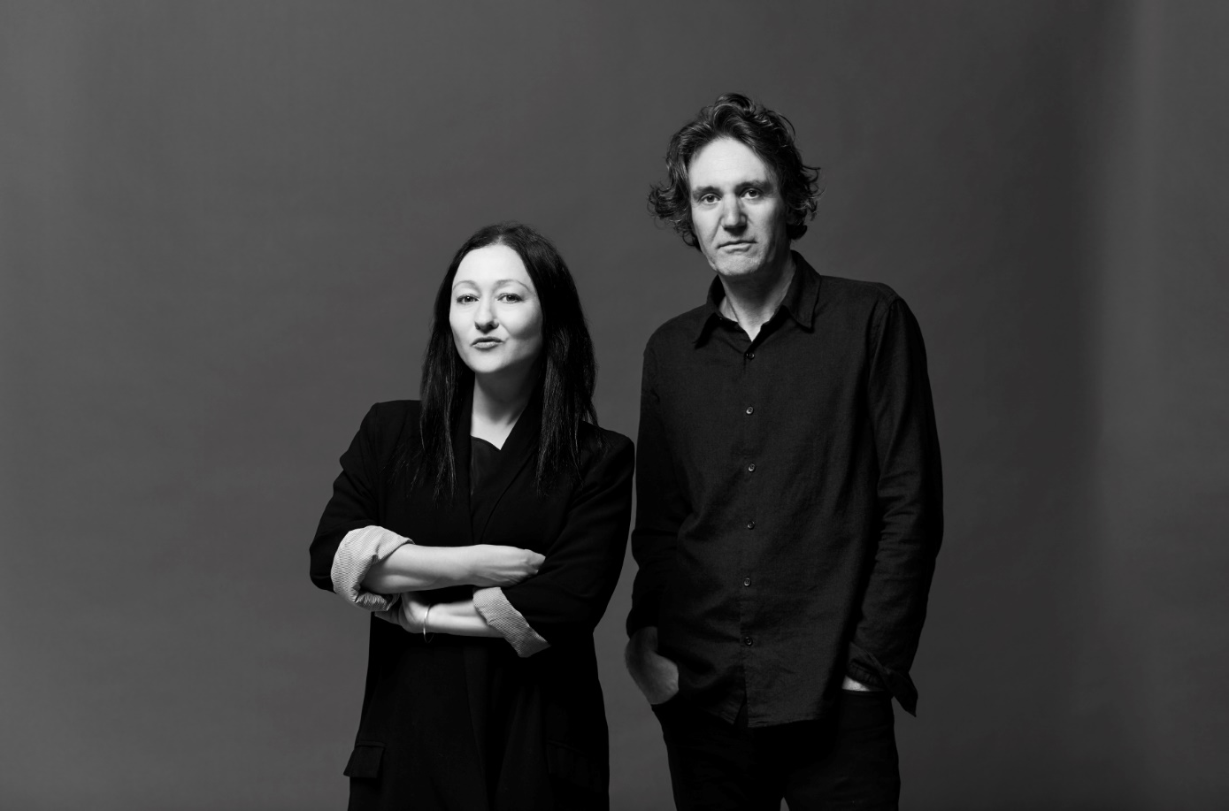 L-R: Alexie Glass-Kantor and Marco Fusinato. Image credits: Zan Wimberley.

(15 December 2021) **Marco Fusinato** and **Alexie Glass-Kantor** are the artist and curator for Australia’s 41st representation at the 59th International Art Exhibition of La Biennale di Venezia from 23 April to 27 November 2022.

Marco Fusinato is a contemporary artist and noise musician whose work has taken the form of installation, photographic reproduction, performance, and recording. He combines powerful imagery with intense immersive walls of sound. As a musician Fusinato is pushing the extremes of noise, using the electric guitar and mass amplification to improvise intricate, wide-ranging and physically affecting frequencies.

Alexie Glass-Kantor is one of Australia’s most highly regarded curators. She is currently the Executive Director of Artspace in Sydney, where she supports the commissioning of contemporary art, publishing initiatives and research residencies, and is the curator of the Encounters sector at Art Basel Hong Kong.

Fusinato’s exhibition will be presented at the award-winning Australian Pavilion designed by Denton Corker Marshall, in the historic Giardini della Biennale. Australia’s representation at the Venice Biennale began in 1954, with 40 distinguished contemporary visual artists since having the opportunity to exhibit under the Australia banner.

The Australia Council for the Arts is the commissioner for Australia in the category of National Participation at the 59th International Art Exhibition of La Biennale di Venezia.

**Australia Council CEO Adrian Collette AM** said: “We are excited to have Marco Fusinato and Alexie Glass-Kantor as Australia’s representatives for the Venice Biennale in 2022. In witnessing their continued collaboration during this period, we look forward to experiencing and sharing this ambitious and unparalleled work at the Biennale Arte.”

**Further details to be announced on the project in early 2022.**

* ENDS -

**For international media enquiries, please contact:**

Alexandra Ross | Sutton

M: +44 (0) 20 7183 3577  | E: [alexandra@suttoncomms.com](mailto:alexandra@suttoncomms.com)

**For media enquiries within Australia and New Zealand, please contact:**

Claire Martin | ARTICULATE

M: +61 (0) 414 437 588 | E: [claire@articulatepr.com.au](mailto:claire@articulatepr.com.au)

**About the Artist: Marco Fusinato**

Marco Fusinato is an artist and musician whose work has taken the form of installation,

photographic reproduction, performance and recording.

His overall aesthetic project combines allegorical appropriation with an interest in the intensity of a gesture or event. His work has been presented in many exhibitions, including ‘*All the World’s Futures*’, the 56th International Art Exhibition of the Venice Biennale, Venice, 2015; ‘*The Imminence of Poetics*’, 30th Sao Paulo Biennale, Sao Paulo, 2012; *‘SUPERPOSITION: Art of Equilibrium and Engagement*’, the 21st Biennale of Sydney, 2018; ‘The National 2017: New Australian Art’, Museum of Contemporary Art Australia, Sydney (2017); Australia: Antipodean Stories, PAC: Padiglione d’Arte Contemporanea, Milan, 2019; His work was also included in ‘*Soundings: A Contemporary Score*’, the first ever exhibition of sound at the Museum of Modern Art, New York, 2013 and ‘Sonic Youth: Sensational Fix’ (2008-2010) a travelling exhibition around European museums of artists that have collaborated with the NYC rock band, Sonic Youth.

Fusinato has held regular solo exhibitions at Anna Schwartz Gallery since 2006, a selection being ‘*EXPERIMENTAL HELL (ATMOSPHÆRAM)*’, 2021; ‘*This is Not My World*’, 2019; ‘*Mass Black Implosion*’, 2017; ‘*The Infinitives*’, 2015; ‘*There is No Authority*’, 2012; ‘*Noise & Capitalism*’, 2010 and ‘*The Approaching of The Disco Void-Repeated*’, 2006.

As a musician Fusinato explores the idea of noise as music, using the electric guitar and mass amplification to improvise intricate, wide-ranging and physically affecting frequencies. His ongoing series of durational noise-guitar performances ‘Spectral Arrows’ – described as a monumental aural sculpture – was first performed at The Glasgow International Arts Festival (2012) and has since been performed in museums and theatres worldwide. He also performs regularly in the experimental music world, primarily as a solo artist. Fusinato’s first recordings were released in 1996 and over the decades has released many other recordings primarily on vinyl format.

Fusinato was recently nominated for two prestigious awards, the Nam June Paik Art Centre Prize, South Korea (2018) and the Nasher Prize, Dallas, USA (2017). He was the recipient of an Australia Council for the Arts Fellowship in 2016.

Marco Fusinato has been selected as the artist to represent Australia at the 59th International

Art Exhibition of the Venice Biennale in 2022.

Marco Fusinato is represented by Anna Schwartz Gallery

<http://marcofusinato.com/info/>

**About the Curator: Alexie Glass-Kantor**

Alexie Glass-Kantor is a curator, advocate for the arts, and the Executive Director of Artspace, Sydney. Since 2014 she has led the opportunity for co-curated and artist-led projects with peer institutions in fourteen countries, including: Jonathan Jones, untitled (transcriptions of country), Palais de Tokyo, (2021); 경로를 재탐색합니다 UN/LEARNING AUSTRALIA, Seoul Museum of Art (2021); Taloi Havini Reclamation, Dhaka Art Summit (2020); Mel O’Callaghan, Centre of the Centre, UQ Art Museum (2020) and Le Confort Moderne (2019); Angelica Mesiti, Relay League, Art Sonje, Seoul (2019), and Kunsthalle Tbilisi, Georgia (2018); Helen Johnson, Institute for Contemporary Art (ICA), London (2017); and Nicholas Mangan, Ancient Lights, Chisenhale Gallery, London (2015).

In 2017 she conceived of 52 ARTISTS 52 ACTIONS, utilising social media to examine socially engaged practice and art-as-action. Since 2015 she is the curator for Encounters for Art Basel | Hong Kong, the sector dedicated to large-scale installations. Glass-Kantor was co-curator with Natasha Bullock of Parallel Collisions the 12th Adelaide Biennial of Contemporary Art and in the curatorium for the 13th SITE Santa Fe Biennial, New Mexico. Glass-Kantor is the Chair of the Contemporary Art Organisations of Australia and is currently serving on boards including: Academic Board, National Art School, Sydney; Advisory Council, Sydney Contemporary; Advisory Board, Museum of Contemporary Art & Design, De La Salle College of Saint Benilde, Manila; Jury Member, Advance Global Awards; and Curatorial Advisory Board, Monash University Curatorial PhD Program. She regularly jury’s art award and prizes, alongside a program of participating in public programs and symposiums and delivering lectures across Australia and internationally.

**About Australia Council**

The Australia Council is the Australian Government's principal arts investment, development and advisory body and the commissioner for Australia at the Venice Biennale. Their purpose is to champion and invest in Australian arts and creativity. Australia Council invests in arts and organisations through peer assessed grants, fellowships and awards that enable art to be created and experienced. Australia’s representation at the Venice Biennale began in 1954, with 40 distinguished contemporary visual artists having the opportunity to exhibit under the Australia banner. Marco Fusinato and Alexie Glass-Kantor make the 41st team to represent Australia within the Australian Pavilion. The Australia at the Venice Biennale project encompasses the National Participation within the Australian Pavilion, a suite of professional development opportunities and a unique co-investment campaign to build advocacy and enable the realisation of the project. The project forms part of Council’s International Engagement Strategy 2021-2025.

**About the Australian Pavilion**

The award-winning Australian Pavilion designed by Denton Corker Marshall opened in 2015. Mathew Doyle of the Muruwari people led the smoking ceremony for the Pavilion’s opening. The Pavilion is the first (and currently only) permanent 21st-century structure built in the Giardini della Biennale.

The Australian Pavilion's form was designed to be as simple as possible. The architects describe it as a "white box within a black box, carefully positioned on the site to ensure minimal impact on the existing landscape". Large slabs of black granite give the building its dark exterior. Some panels fold open to reveal the clean white interior and allow some natural light inside. These protruding panels aim to enable the building to take on a new appearance when an exhibition is taking place.

Australia’s Pavilion is one of only 29 national pavilions within the Biennale Gardens, all built at different periods by various countries. The development of the Australian Pavilion was made possible through a public-private partnership led by the Australia Council with the then Commissioner Simon Mordant AM. The original pavilion, designed as a temporary structure by Philip Cox, opened in 1988 and hosted 22 artists during its lifetime.