Tuesday 19 April 2022

***DESASTRES* by Marco Fusinato**

**Experimental noise project opens at the Australia Pavilion**

**for the 59th International Art Exhibition of La Biennale di Venezia**

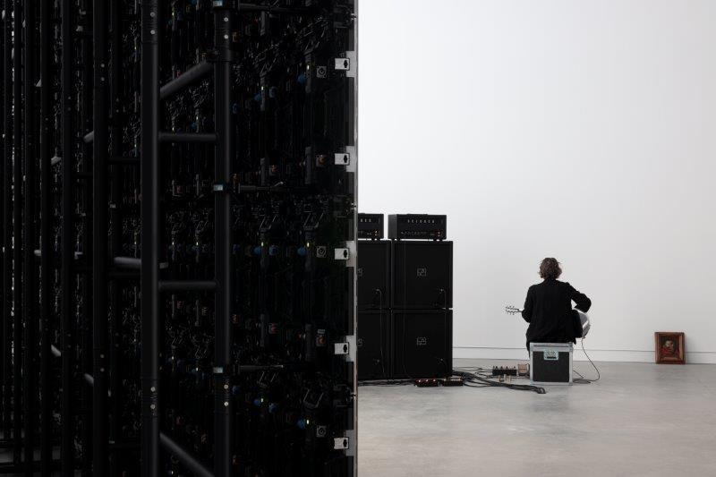 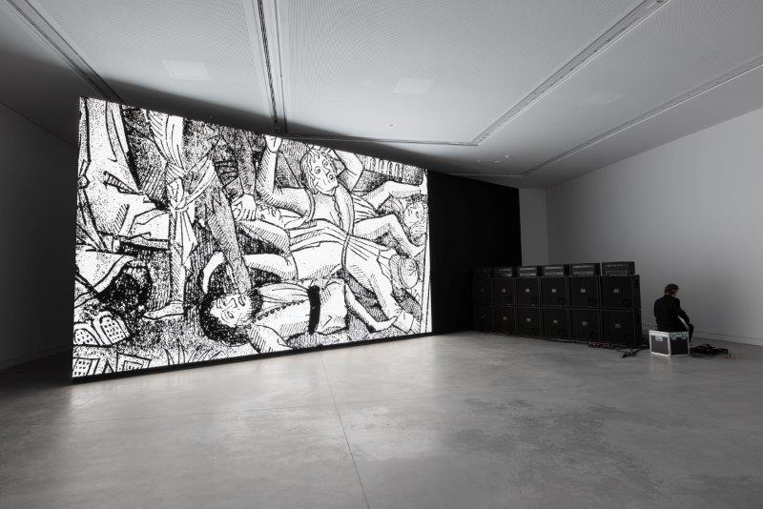

*Marco Fusinato,* DESASTRES*, 2022, solo durational performance as installation, 200 days. Installation views, Australia Pavilion, 59th International Art Exhibition of La Biennale di Venezia, 2022. Photo: Andrea Rossetti*

* **The Australia Council for the Arts unveils *DESASTRES* by Marco Fusinato curated by Alexie Glass-Kantor in the Giardini** **della Biennale.**
* ***DESASTRES* will be performed by the artist every day of La Biennale Arte 2022 – 200 days in total.**
* **Fusinato’s ability to orchestrate spectacles and conceptually bring together vast swathes of art-historical and cultural references lies at the core of *DESASTRES*.**
* **Audiences will be able to engage with *DESASTRES* digitally via Instagram @desastres_desastres, desastresdesastres.com, and a livestream on Saturday 23 April 2022.**

*DESASTRES* by Marco Fusinato has made its debut in the Australia Pavilion in the Giardini della Biennale.

Curated by Alexie Glass-Kantor, *DESASTRES* will be live for the entirety of La Biennale Arte 2022. The work is an invitation for audiences to come together within a high-intensity concentration of energy. What can’t be seen, can be felt: sound as physical matter which creates a transformative experience.

In the installation for *DESASTRES*,Fusinato uses equipment associated with spectacle as a form of sculpture. The work is unique each day it is initiated and, as it unfolds, it will radically transform the physical experience of each audience member. **Fusinato says**: “My idea of activating the audience is to remind them that they are alive. That they have a pulse”.

The large-scale, immersive artwork sees Fusinato improvising slabs of noise, saturated feedback and discordant intensities with an electric guitar, triggering a deluge of disparate and disconnected images onto a freestanding floor-to-ceiling LED wall. The pavilion is simultaneously a de facto studio and a space for research where Fusinato can test cause and effect in real time.

The images are sourced via a stream of words that have been put into an open search across multiple online platforms. There is no theme as such, rather the immersion of sound and image is open for the audience to interpret and make sense of. The intent is to create some kind of hallucination, elation in disorientation and exhaustion from confusion.

**Glass-Kantor says**: “*DESASTRES* is a monster. A banquet of images that range from the benign to the blatant, absurd, twisted, sublime, bone-crushing and tense. The images build accumulatively, treading judiciously between chaos and intent. The audience for *DESASTRES* are witnesses who can no longer observe, singularly, anything. The perennial image."

The piece is a culmination of Fusinato’s interests in experimental music, underground culture, mass media images and history painting. The performance explores the topics of labour, perseverance, and absenteeism through his ongoing presence (and absence) in the space. The title was influenced by the output of Japanese doom metal band Corrupted, whose lyrics are always written in Spanish, and the context in which Goya made his series *Los Desastres de la Guerra* (1810–20).

**Fusinato says**: “I’m aware that my references are pretty oblique, marginal, unpopular. And I have no expectation that what I do will be ‘liked’ so I’m never disappointed.”

Two material elements make up the installation, the freestanding floor-to-ceiling LED wall and the wall of amplification, both of which have been selected by the artist for their sculptural form and presence. The sheer scale of the LED wall that occupies the space overwhelms audiences with the images generated by the artist via a custom-built control unit. At its slowest setting, one image can be released for a whole day, at its fastest sixty images can be released per second. The artist will continue to bring into the pavilion objects that will trigger an expanded approach to the work. A 17th century Italian painting of a decapitated head is the *DESASTRES* mascot.

Originally from the foothills of the Dolomite ranges just under 100 kilometres north of Venice, Fusinato’s parents migrated to Australia where Fusinato was born. His ancestral relationship to Venice has a poetic fate – his return to the region to represent Australia, the country where his parents sought a new life.

**Fusinato says: “**I’m going back to exactly the same place my parents migrated from to represent the country they migrated to. There’s a collapse of time”.

**Glass-Kantor says:** “*DESASTRES* places the audience at the centre of the work. It’s through the combination of sound and image that audiences will experience the installation and performance. *DESASTRES* will offer a very physical experience, of feeling as much as seeing and hearing, immersed in the intensity of sound and images. The resulting all-consuming experience is open for the audience to interpret and make sense of”.

The Australia Council for the Arts is the Commissioner for Australia's National Participation at the 59th International Art Exhibition of La Biennale di Venezia.

**Australia Council CEO Adrian Collette AM says:** “There will be nothing shy about the Australia Pavilion this year. And following the turmoil of recent years, this exhibition in Venice is set to be one of the most highly anticipated. Marco Fusinato’s *DESASTRES,* curated by Alexie Glass-Kantor promises an experience like no other. As the first durational work to be presented at the Australia Pavilion, it will also be a feat of endurance for the artist.

This important project is made possible thanks to a successful model of public and private investment. Australia’s presence in Venice is a valuable opportunity to showcase Australian arts and culture on a global platform, and to provide opportunities for arts professionals through our connected professional development programs.”

Audiences unable to travel to Venice can experience part of the project via a public livestream on Saturday 23 April, and follow the durational performance via the Instagram channel, @desastres_desastres, and the project’s website, www.desastresdesastres.com, where samples of Fusinato’s performance are released daily.

The exhibition is accompanied by a publication that is co-published by the Australia Council and Lenz and distributed by Lenz. It features a new essay by Branden W Joseph, professor of art history at Columbia University and an extensive interview by Alexie Glass-Kantor with Marco Fusinato. It also includes texts by critical theorist and filmmaker Elizabeth Povinelli, AI researcher and author Kate Crawford, writer and curator Chus Martinez, and musicians/outre-guitarists Thurston Moore (Sonic Youth), Stephen O’Malley (SUNN O)))) and Bruce Russell (Dead C).

www.desastresdesastres.com

www.australiacouncil.gov.au

**Follow us on:**

Instagram @desastres_desastres

@AusatVenice

Facebook @AusatVenice

**To view the livestream on Saturday 23 April, click** [**here**](https://australiacouncil.gov.au/advocacy-and-research/events/australia-at-the-venice-biennale/venice-biennale-2022/)**.**

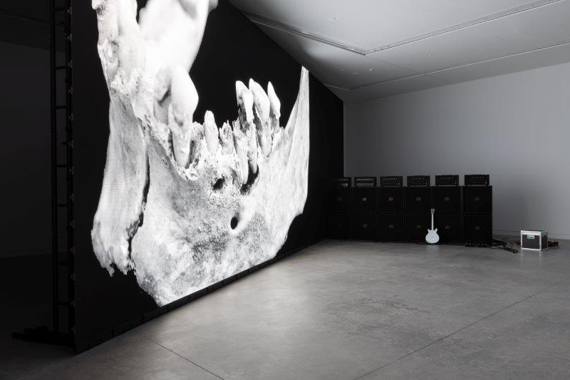

*Marco Fusinato,* DESASTRES*, 2022, solo durational performance as installation, 200 days. Installation view, Australia Pavilion, 59th International Art Exhibition of La Biennale di Venezia, 2022. Photo: Andrea Rossetti*

**For international media enquiries, please contact:**

Alexandra Ross | Sutton

+44 (0) 20 7183 3577 | E: alexandra@suttoncomms.com

**For media enquiries within Australia and New Zealand, please contact:**

Claire Martin | ARTICULATE

+61 (0) 414 437 588 | E: claire@articulatepr.com.au

**Please** [click here](https://australiacouncil.gov.au/advocacy-and-research/events/australia-at-the-venice-biennale/venice-biennale-2022/media-centre/) **to download hi-resolution images and portraits**

**#ausatvenice #australianpavilion #biennalearte #auspavteam22**

**About the Artist: Marco Fusinato**

Marco Fusinato is a contemporary artist and noise-musician whose work takes the form of installation, photographic reproduction, design, performance and recording.

As an artist, he conceives his work as a succession of interrelated projects, some of which continue across numerous iterations. Within these projects the works are almost always serial and use specific frameworks for experimentation, as if demonstrating a thesis. Working across disciplines and cultural fields, Fusinato explores the tensions and contradictions of opposing forces: underground culture/institutions, noise/silence, minimalism/maximalism, purity/contamination. He creates dynamic situations in which these energies are captured by combining allegorical appropriation with an interest in the intensity of a gesture or event.

Fusinato’s work has been presented in many international exhibitions, including *All the World’s Futures*, 56th International Art Exhibition of La Biennale di Venezia (2015); *The Imminence of Poetics*, 30th Sao Paulo Biennale (2012); *SUPERPOSITION: Art of Equilibrium and Engagement*, 21st Biennale of Sydney (2018); and *Australia: Antipodean Stories*, Padiglione d’Arte Contemporanea, Milan (2019). His work was also included in *Soundings: A Contemporary Score*, the first ever exhibition of sound at the Museum of Modern Art, New York (2013) and *Sonic Youth etc.: Sensational Fix* (2008–10), a European travelling exhibition of artists who have collaborated with the New York rock band, Sonic Youth.

Fusinato has held regular solo exhibitions at Anna Schwartz Gallery since 2006 including *EXPERIMENTAL HELL (ATMOSPHÆRAM)* (2021); *THIS IS NOT MY WORLD* (2019); *Mass Black Implosion* (2017); *The Infinitives* (2015); *Mass Black Implosion (Treatise, Cornelius Cardew)* (2013); *THERE IS NO AUTHORITY* (2012); *Noise & Capitalism* (2010); *Double Infinitives* (2009) and *The Approaching of The Disco Void-Repeated*, (2006). He has exhibited in numerous solo and group exhibitions in Australian galleries and museums including *The National: New Australian Art*, Museum of Contemporary Art Australia (2017), Sydney; *Parallel Collisions*, Adelaide Biennale of Australian Art, Art Gallery of South Australia, Adelaide (2012); *Melbourne Now*, National Gallery of Victoria, Melbourne (2013); *New09*, Australian Centre for Contemporary Art, Melbourne (2009); and multiple iterations of *Dark Mofo*, Museum of Old and New Art, Hobart (2021, 2019, 2017, 2016, 2014). In 2012 he presented *The Color of the Sky Has Melted*, a survey exhibition at Artspace, Sydney and IMA, Brisbane.

As a musician Fusinato explores the idea of noise as music, using the electric guitar and mass amplification to improvise intricate, wide-ranging and physically affecting frequencies. His ongoing series of durational noise-guitar performances *Spectral Arrows* – described as a monumental aural sculpture – was first performed at The Glasgow International Arts Festival in 2012 and has since been performed in museums and theatres worldwide. He also performs regularly in the experimental music underground, primarily as a solo artist. Fusinato’s first recordings were released in 1996 and he has released many more over subsequent decades, primarily on vinyl format.

Fusinato was the recipient of an Australia Council for the Arts Fellowship in 2016.

Marco Fusinato is represented by Anna Schwartz Gallery.

**About the Curator: Alexie Glass-Kantor**

Alexie Glass-Kantor is a curator, an advocate for the arts and the Executive Director of Artspace, Sydney. Since 2014 she has led the opportunity for co-curated and artist-led projects with peer institutions in 14 countries, including: *Jonathan Jones: untitled (transcriptions of country),* Palais de Tokyo, Paris (2021); 경로를 재탐색합니다 *UN/LEARNING AUSTRALIA*, Seoul Museum of Art (2021); *Taloi Havini:* *Reclamation*, Dhaka Art Summit (2020); *Mel O’Callaghan: Centre of the Centre*, UQ Art Museum, Brisbane (2020) and Le Confort Moderne, Poitiers (2019); *Angelica Mesiti:* *Relay League*, Art Sonje, Seoul (2019) and Kunsthalle Tbilisi, Georgia (2018); *Helen Johnson*, Institute for Contemporary Art, London (2017); and *Nicholas Mangan*: *Ancient Lights*, Chisenhale Gallery, London (2015).

In 2017 Glass-Kantor conceived *52 ARTISTS 52 ACTIONS*, a project which utilised social media to examine socially engaged practice and art-as-action. Since 2015 she has been the curator of *Encounters* for Art Basel | Hong Kong, dedicated to large-scale installations. Glass-Kantor was co-curator with Natasha Bullock of *Parallel Collisions*, the 12th Adelaide Biennial of Contemporary Art (2012) and was in the curatorium for the 13th SITE Santa Fe Biennial, New Mexico. Glass-Kantor is Chair of the Contemporary Art Organisations of Australia and serves on a number of boards and juries including: Academic Board, National Art School, Sydney; Advisory Council, Sydney Contemporary; Advisory Board, Museum of Contemporary Art & Design – De La Salle College of Saint Benilde, Manila; Advance Global Awards jury; and Curatorial Advisory Board, Monash University Curatorial Practice PhD Program. She regularly sits on selection panels for art award and prizes, and participates in public programs, symposiums and lectures across Australia and internationally.

**About Australia Council for the Arts**

The Australia Council is the Australian Government's principal arts investment, development and advisory body and the commissioner for Australia at La Biennale di Venezia. Its purpose is to champion and invest in Australian arts and creativity. The Australia Council invests in arts and organisations through peer assessed grants, fellowships and awards that enable art to be created and experienced.

Australia’s representation at La Biennale Arte in Venice began in 1954, with 40 distinguished contemporary visual artists having the opportunity to exhibit under the Australia banner. Marco Fusinato and Alexie Glass-Kantor make the 41stteam to represent Australia within the Australia Pavilion. The multifaceted project known as Australia at La Biennale Arte encompasses the National Participation within the Australia Pavilion, a suite of professional development opportunities, and a unique co-investment campaign which builds advocacy and enables the realisation of the project. The project forms part of Council’s International Engagement Strategy 2021–25.

**About the Australia Pavilion**

The award-winning Australia Pavilion designed by Denton Corker Marshall opened in 2015. Mathew Doyle of the Muruwari people led the smoking ceremony for the Pavilion’s opening. The Pavilion is the first (and currently only) permanent 21st-century structure built in the Giardini della Biennale.

The Australia Pavilion's form was designed to be as simple as possible. The architects describe it as a "white box within a black box, carefully positioned on the site to ensure minimal impact on the existing landscape". Large slabs of black granite give the building its dark exterior. Some panels fold open to reveal the clean white interior and allow some natural light inside. These protruding panels aim to enable the building to take on a new appearance when an exhibition is taking place.

Australia’s Pavilion is one of only 29 national pavilions within the Biennale Gardens, all built at different periods by various countries. The development of the Australia Pavilion was made possible through a public-private partnership led by the Australia Council with the then Commissioner Simon Mordant AM. The original pavilion, designed as a temporary structure by Philip Cox, opened in 1988 and hosted 22 artists during its lifetime.